**AWS SQS , Amazon MQ**

**Step 1: Create a Queue**

1. **Sign in to the AWS Management Console.**
2. **Navigate to Amazon SQS (Simple Queue Service).**
3. **Click Create Queue.**
4. **Choose Standard Queue (FIFO behaves differently).**
5. **Enter a name, e.g. demo-queue.**
6. **Leave default settings (e.g., Visibility Timeout = 30s).**
7. **Click Create Queue.**

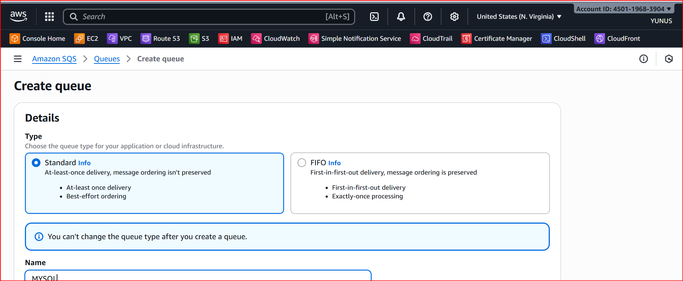

**Step 2: Send a Message**

1. **In the AWS Console, open your queue (demo-queue).**
2. **Click Send and receive messages.**
3. **In the Message body, type something like:**
4. **Hello, this is my first message!**
5. **Hello, this is my second message!**
6. **Leave other settings as default.**
7. **Click Send message.**

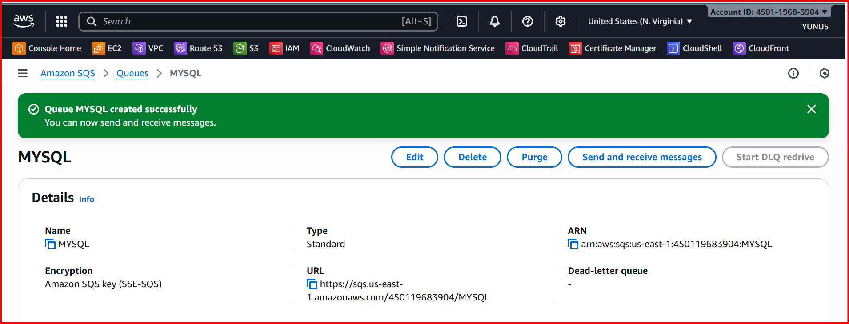

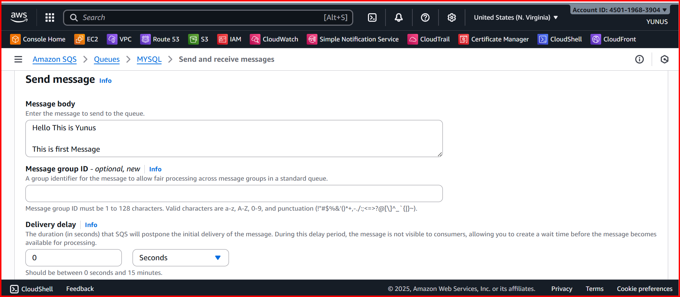

**Step 3: Poll for Messages**

1. **In the same Send and receive messages screen, click Poll for messages.**
2. **You’ll see your messages appear in the Message list.**

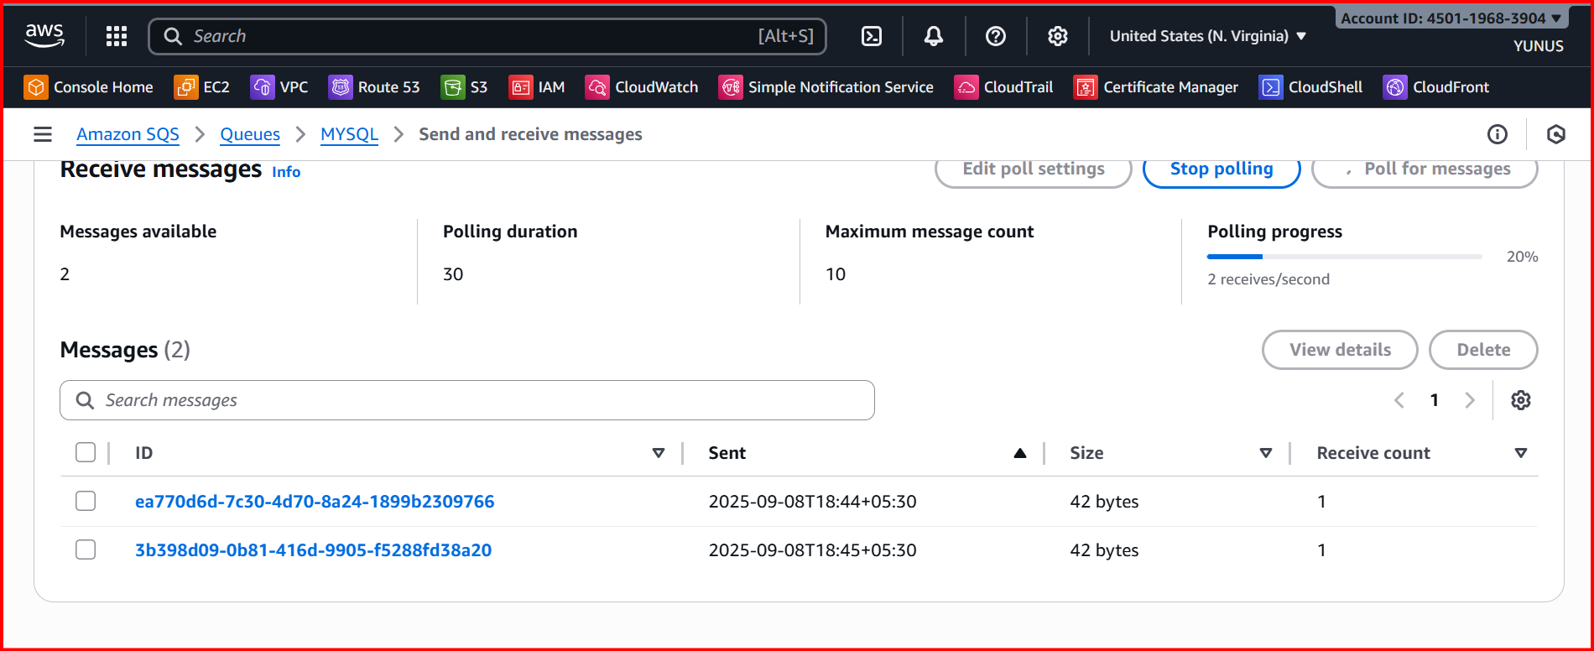

**Send → Poll → Delete is the full lifecycle of an SQS message.**

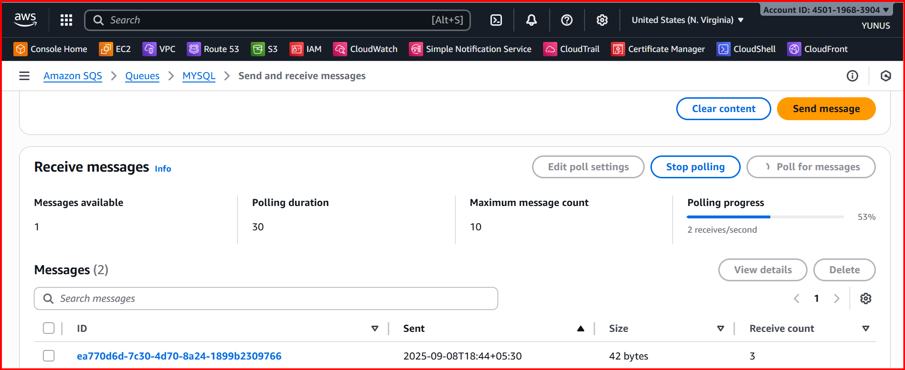

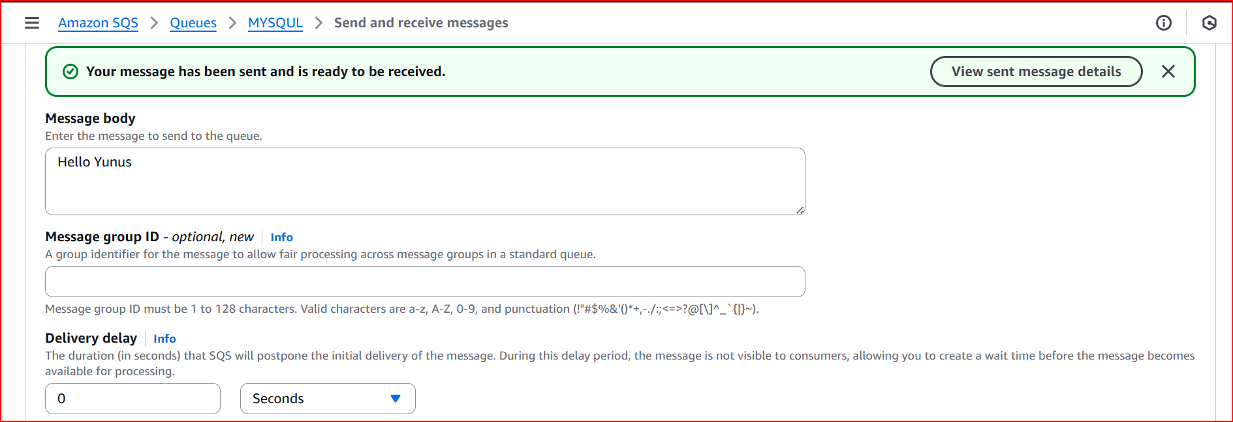

**sends a message to an SQS queue.**

**The message stays in the queue until a consumer retrieves it.**

**The consumer processes the message.**

**Once processed, the message is deleted from the queue.**

**Amazon MQ**

**Create a broker (AWS Management Console)**

1. **Sign in to the Amazon MQ console.**
2. **Select broker engine: choose Apache ActiveMQ or RabbitMQ.**
3. **Choose deployment & storage:**
   * **For ActiveMQ: SINGLE_INSTANCE or ACTIVE_STANDBY_MULTI_AZ**

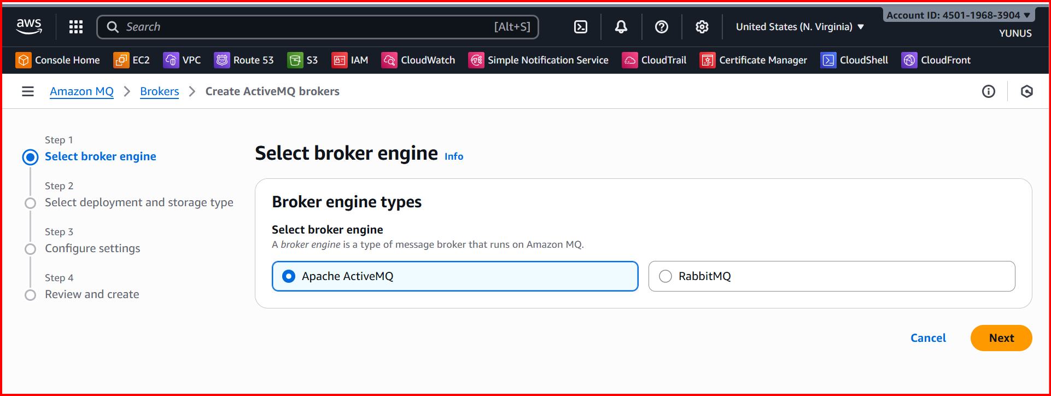

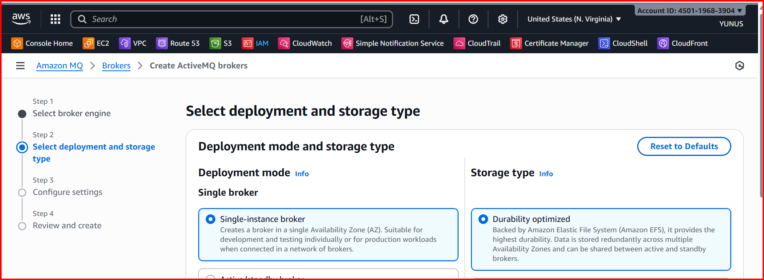

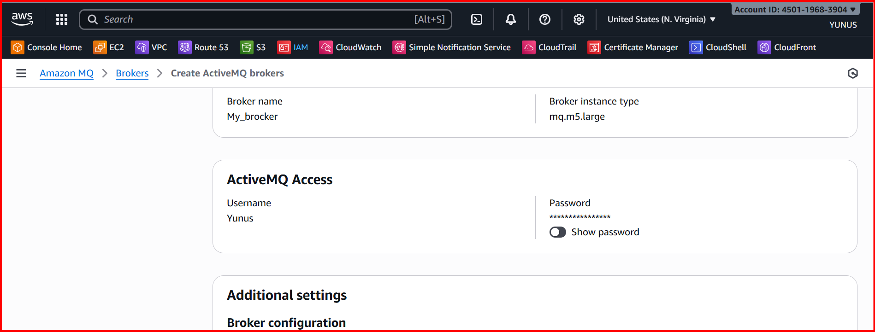

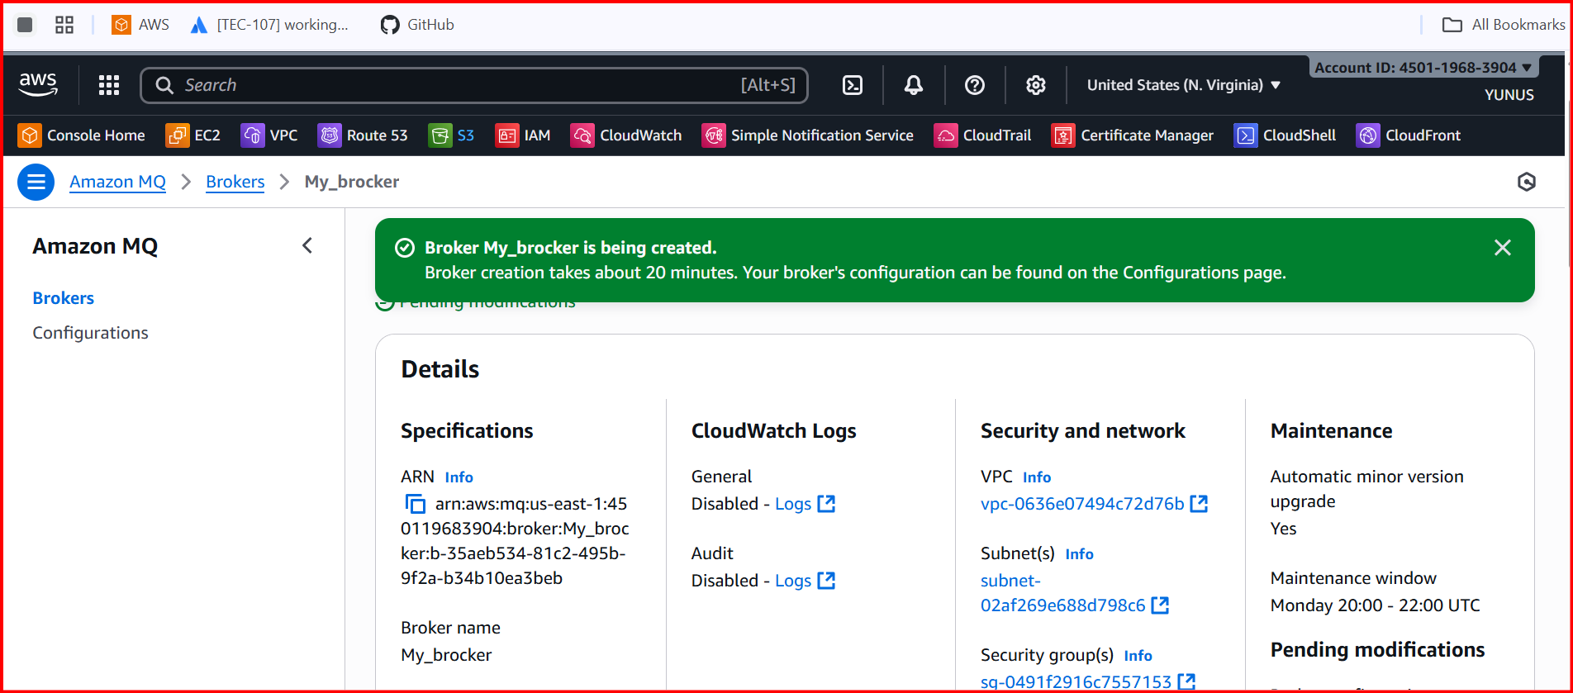

[**https://b-35aeb534-81c2-495b-9f2a-b34b10ea3beb-1.mq.us-east-1.amazonaws.com:8162/index.html**](https://b-35aeb534-81c2-495b-9f2a-b34b10ea3beb-1.mq.us-east-1.amazonaws.com:8162/index.html)

**It will take some time to provision it**

**Once done past the above link in browser and check**

**Amazon MQ will be activated**

